Name:__________________________ Date:_________

Homework sheet: Alg2H

Relations, Functions, Domain and Range

1. Given the equation

$y=|x-1|$,

complete the below table, graph, domain and range, and whether the equation describes a function.



|  |  |
| --- | --- |
| x | y |
|  |  |
|  |  |
|  |  |
|  |  |
|  |  |
|  |  |
|  |  |

Domain:_______________

Range:_________________

Function:_______________

1. Given the equation

$y=-2+\sqrt{16-x^{2}}$,

complete the below table, graph, domain and range, and whether the equation describes a function.



|  |  |
| --- | --- |
| x | y |
|  |  |
|  |  |
|  |  |
|  |  |
|  |  |
|  |  |
|  |  |

Domain:_______________

Range:_________________

Function:_______________

1. Given the equation

$h(t)=200+96⋅t-16⋅t^{2}$,

and the Domain

$$t∈\left[0,8\right]$$

complete the below table, graph, range, and whether the equation describes a function.

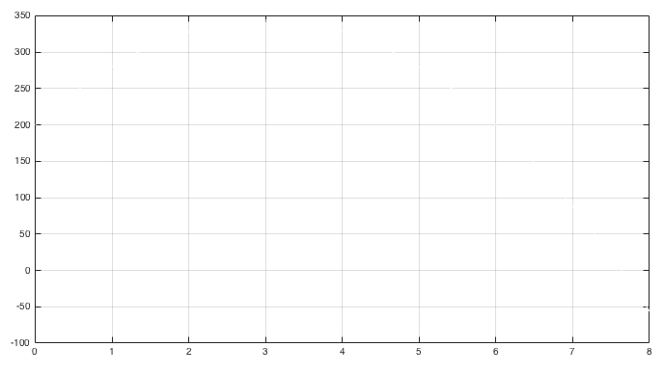

|  |  |
| --- | --- |
| t | H |
|  |  |
|  |  |
|  |  |
|  |  |
|  |  |
|  |  |
|  |  |

Domain: $t∈\left[0,8\right]$

______

Range:_________________

Function:_______________

==== End ====